(Insert provider logo)
Insert Provider Name, Address & Contact Information

Verifying Tax Based Net Income

To Click or tap here to enter text.:

Household members whose income is to be included in the rent calculation are required to file their income tax returns annually as a condition of initial or continued eligibility for a social housing subsidy.

Our office is requesting that you provide the following:

□ Proof of Income Statement
A proof of income statement is a simple version of your Income Tax Assessment that summarized your income and deductions for the tax year. The attached provides instructions on how to complete this.

□ Notice of Assessment
Your notice of assessment (NOA) is an evaluation of your tax return that the Canada Revenue Agency sends you every year after you file your tax return.

□ File your Income Tax
Filing Income Tax ensures that you receive the refunds, benefits, or credit payments that you may be entitled to. CRA has digital services to assist with filing. By filing online and using CRA’s digital services, you can improve how fast your assessment is processed.Check out CRA’s step-by-step guide about how to get started.

Please submit the above by Click or tap here to enter text.. If not returned, you may be made ineligible for RGI which means you may be charged the market rent/housing charge for your unit.

If you have any questions, please call Click or tap here to enter text. at Click or tap here to enter text..

Sincerely,

Click or tap here to enter text.
Click or tap here to enter text.

Options for acquiring proof of income statements:

Option 1:
You can get a Proof of Income Statement from the Canada Revenue Agency (CRA) online or by mail.

Online
The CRA My Account is a secure portal that lets you view your personal income tax and benefit information and manage your tax affairs online.

If you are not already registered for My Account, you can sign up on the CRA website. There is a helpful video on the CRA site to walk you through how to register.

If you received an Income Tax refund or Canada child benefits (CCB), you likely are already registered for My Account, and you can easily print a Proof of Income Statement.

1. Login into your CRA My Account online (http://www.cra-arc.gc.ca/myaccount/)

2. Click the “Proof of income statement (option ‘C’ print)” link under the “Related services” section in the bottom right corner
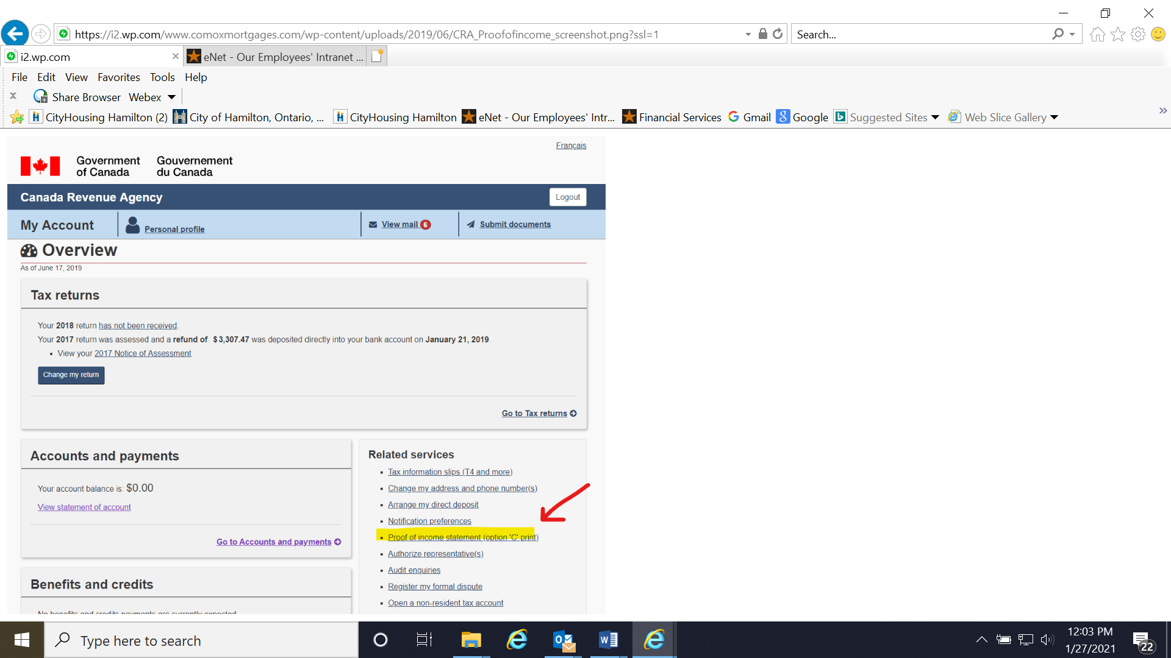
3. Select the Tax Year from the drop-down list that you want to see.
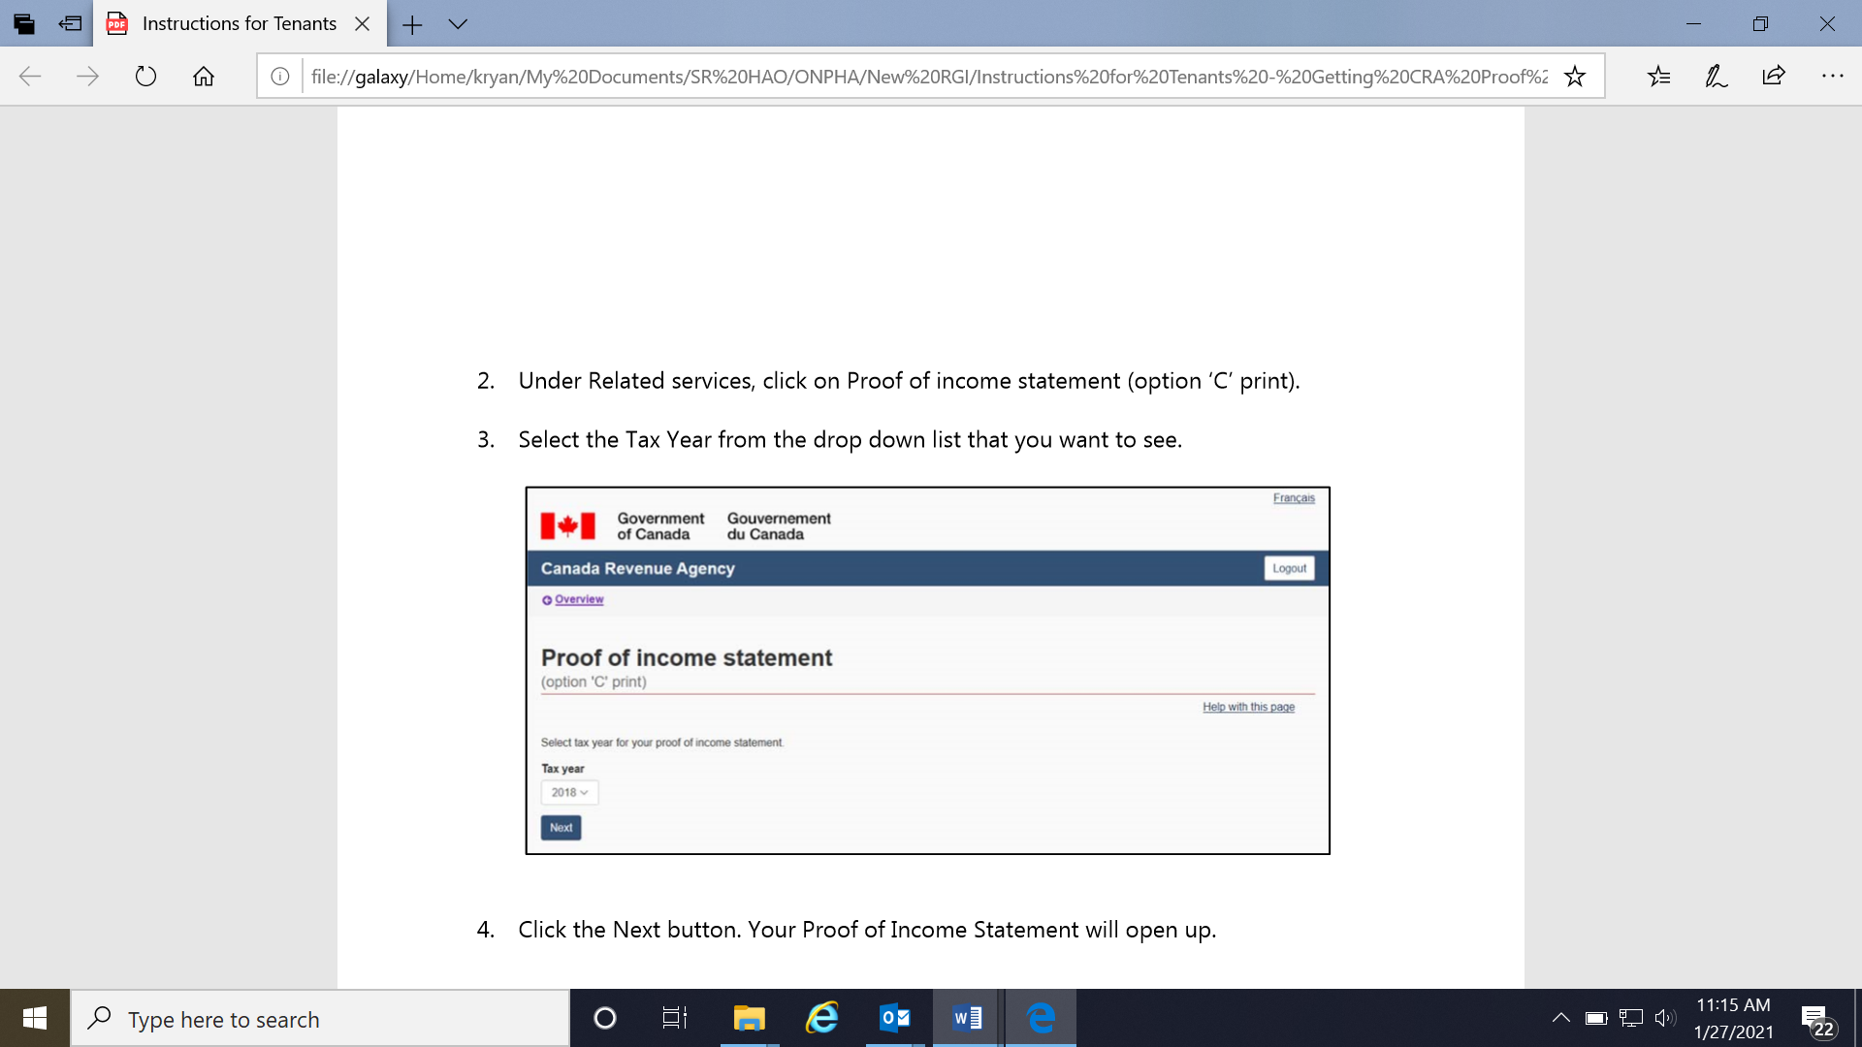

4. Click the Next button. Your Proof of Income Statement will open up.
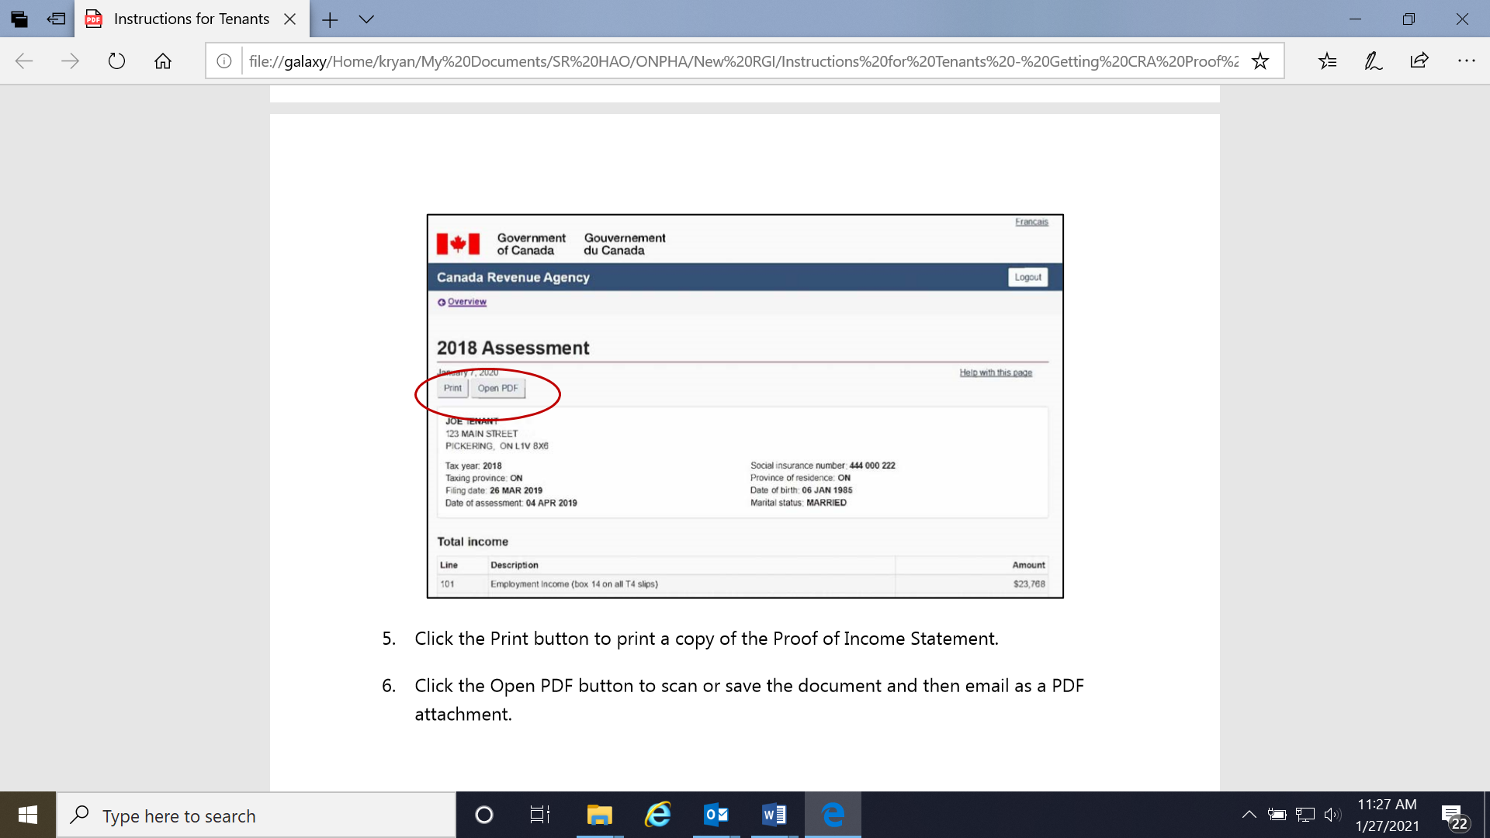

5. Press the Print button to generate a paper copy to bring in, or the Open PDF button if you’d like to save the PDF file and save it electronically.

Option 2:

By Mail
You can order a copy of the Proof of Income Statement (option "C" print) to be mailed to you by calling the automated Canada Revenue Agency (CRA) line at 1-800-267-6999.

You will need to verify your identity when you call. You will need:
- Your full name and date of birth
- Your social insurance number (SIN)
- Your complete address, including postal code
- Line 150 from your most recent tax assessment

It can take up to 10 days to receive the Proof of Income Statement by mail.

